**Classroom Management System**

**Requirement Analysis and Feasibility Study**

**Prepared By:**

1005002 - Ahamed Al Nahian

1005006 – Abdul Kawsar Tushar

1005015 – Sheikh Moinul Hasan

1005017 – Mostafizur Rahman

1005027 – Ifta Noor Mahmood

**Table of Contents**

* 1. Fishbone Diagram
  2. Feasibility

2.1 Operational

2.2 Cultural

2.3 Technical

2.4 Schedule

2.5 Economic

* 1. Data Flow Diagram

3.1 Account Management System

3.2 Course Content Management System

3.3 Exam and class management system

3.4 Notification and Warning system

3.5 Interactive routine system

* 1. **Account Management System Fishbone Diagram**

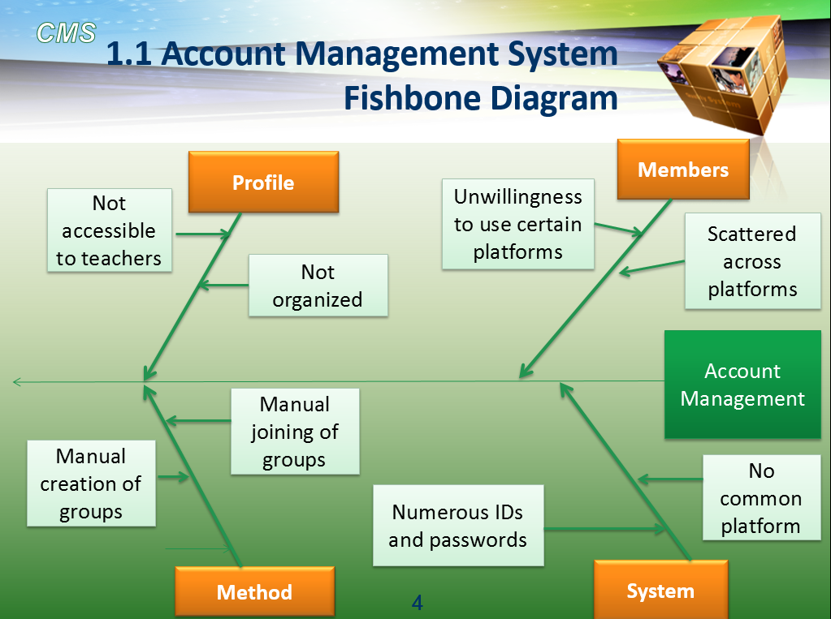

* 1. **Course Content Management System Fishbone Diagram**

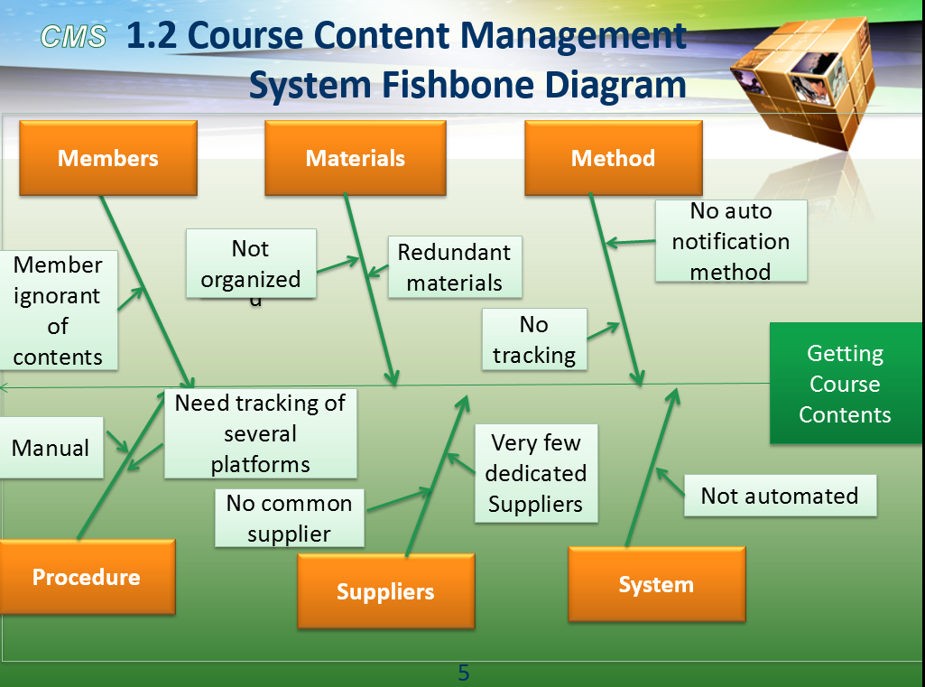

* 1. **Exam and Class Management System Fishbone Diagram**

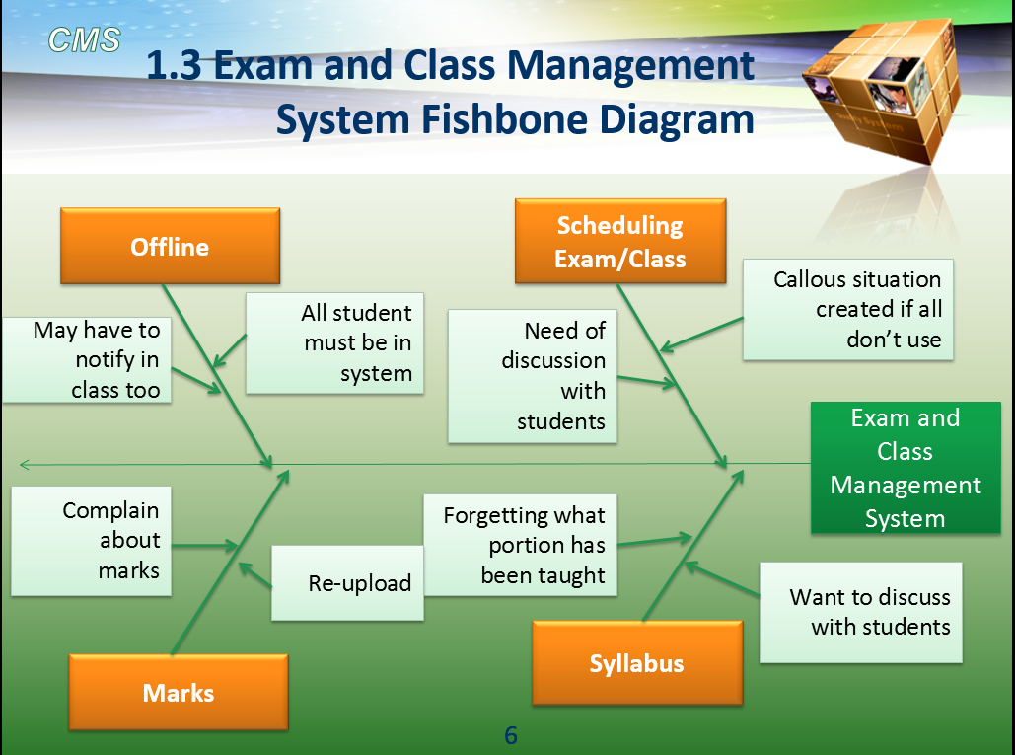

* 1. **Notification and Warning System Fishbone Diagram**

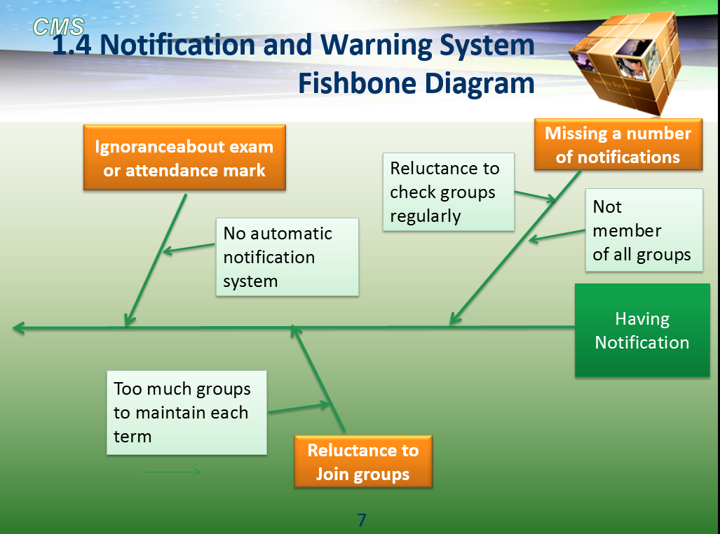

* 1. **Interactive Routine System Fishbone Diagram**

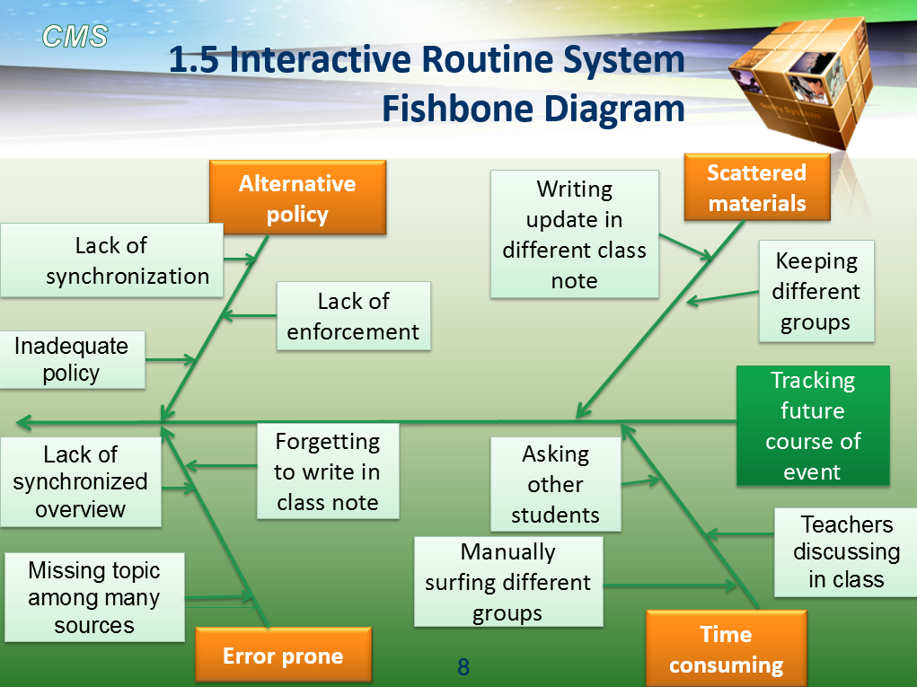

**Feasibility Studies**

**2.1 Operational Feasibly**

* Automated System saving time of both teachers and students
* Only one place to find all necessary contents
* No need to search to others for course contents as it will always be saved in a specific place
* Easy and low maintenance

**2.2 Cultural Feasibility**

* **Definition:** A measure of how the end users feel about the proposed system
  + Multicultural organizations
  + Change of information structure -> change of power structure
* Official directive for teachers and students preferring Facebook/Google groups
* Mobile application / Facebook application for students who might not have time or forget to check system
* Training session for teachers might be reluctant to use system
* Greater responsibility on CR when teacher is unavailable

**2.3 Technical Feasibility**

* Issue 1: Is the proposed technology or solution is practical?
  + The proposal was to build an web based information system which is practical and easily implementable.
* Issue 2: Do we currently possess the necessary technology

|  |  |
| --- | --- |
| **Required Technology** | **Status** |
| Servers | Available |
| Personal Computers | Available |
| Internet | Available |
| Web based programming language | There are enormous web based programming languages |
| Data base | Oracle or SQL database can be made. |

* Issue 3: Do we possess the necessary technical expertise?
  + Yes, we do.

**2.4 Schedule Feasibility**

* The system is certainly necessary but not a crying need at the recent time. But Its necessity will increase with every passing second.
* The system may have relatively less benefit when first starts, but as time progresses the course content will increase and will become more beneficial.
* Once the system is developed, people will get benefitted for a long time.
* It also will not take much time to develop, it can be developed to perform its basic action within a very reasonable time.
* Technology will be more prevalent with time, so the scope will increase, but substantially later in the future.
* The project will never get obsolete with respect to its use, as number of users will only increase with time.
* Upon considering the above points it can be seen that the project can be completed much before the project or technology become obsolete.

**2.5 Economic Feasibility**

* **Cost:**
  + Development cost:
    - Manpower: 5/6 system developer and 1/2 personnel for data entry  
      Rough estimate: 500,000/-
    - Server rent: 4000/-
  + Operating cost:
    - Fixed costs:
      * Periodic checking and maintenance
      * server rent: 4000/year
    - Variable costs:

**Bottom line:**

* Development cost and operating cost are relatively very low compared to a university’s annual budget.
* BUET spends around 91.33 crore a year.  
  [Ref - <http://www.eduicon.com/News/Details/3011.html>]
* **Benefits:**

Tangible benefit:

* + As the project is not intended for business purposes it does not recur tangible benefits.
  + Some advertisement and sponsor offer can be obtained in future.

Intangible benefit:

* + Saving time of thousands of student. If the system saves 1 hour per day of each student then it will amount to a tremendous amount for all students over years of study.
  + No headache of getting used to with new platforms for each course each semester.
  + Saving labor for collecting different materials like previous years course materials etc.

**3.1 Account Management System DFD**

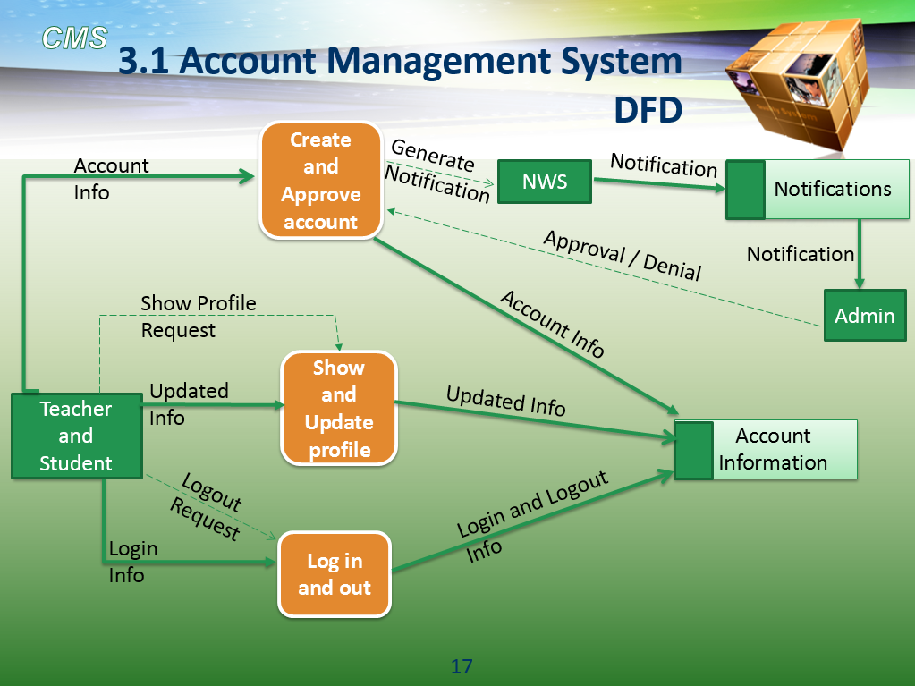

**3.3 Exam and Class Management System DFD**

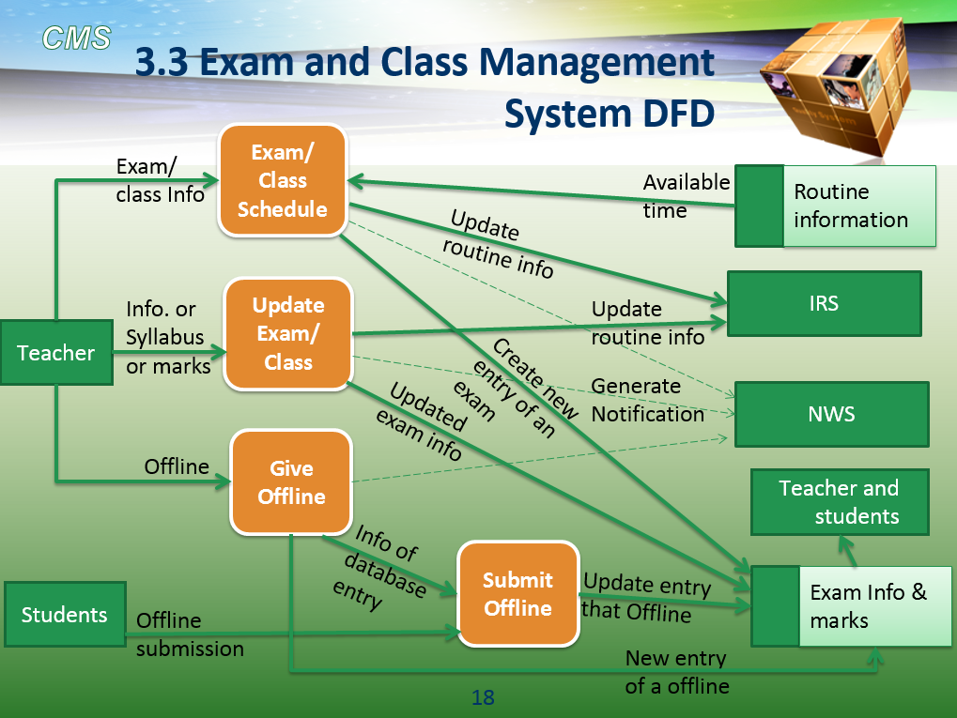

**3.4 Notification and Warning System DFD**

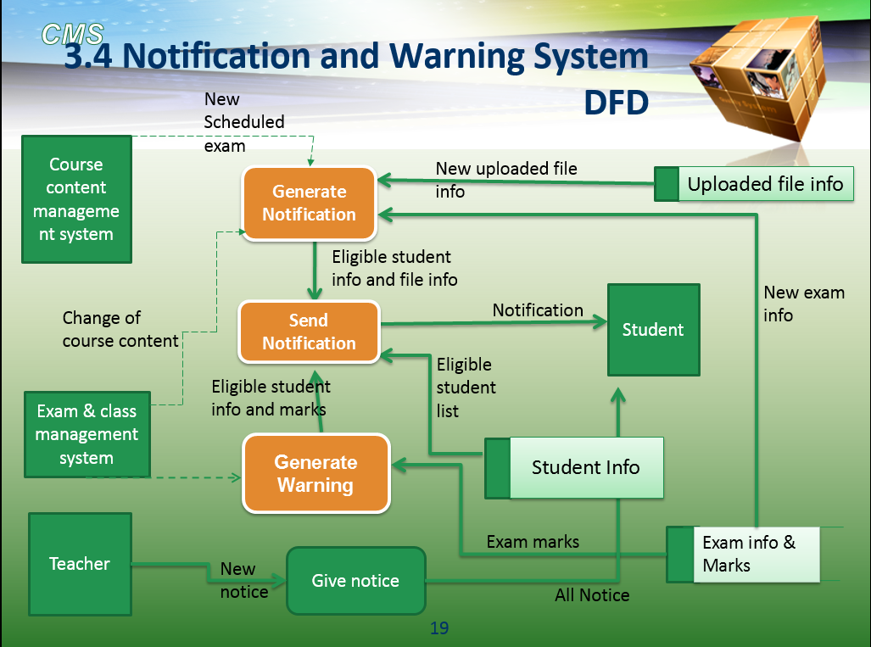

**3.5 Interactive Routine System DFD**

